Experiment 7
AIM: Develop Feedback Management Module using MVC Layout, Partial View & Validation
Source: App_Start/RouteConfig.cs
Code:
using System;
using System.Collections.Generic;
using System.Linq;
using System.Web;
using System.Web.Mvc;
using System.Web.Routing;

namespace Practical_7
{
public class RouteConfig
{
public static void RegisterRoutes(RouteCollection routes)
{
routes.IgnoreRoute("{resource}.axd/{*pathInfo}");

routes.MapRoute(
name: "Default",
url: "{controller}/{action}/{id}",
defaults: new { controller = "feedback", action = "Index", id = UrlParameter.Optional }
);
}
}
}

Source: Controllers/feedbackController.cs

Code:
using Practical_7.Models;
using System;
using System.Collections.Generic;
using System.Linq;
using System.Web;
using System.Web.Mvc;

namespace Practical_7.Controllers
{
public class feedbackController : Controller
{
// GET: feedback
public ActionResult Index()
{
return View("feedback");
}

[HttpPost]

public ActionResult feedback(feedback model)
{
if (ModelState.IsValid)
{
return View("thankyou", model);
}
return View(model);
}
}
}

Source: Models/feedback.cs

Code:

using System;
using System.Collections.Generic;
using System.ComponentModel.DataAnnotations;
using System.Linq;
using System.Web;

namespace Practical_7.Models
{
public class feedback
{
[Required]
public string Name { get; set; }

[Required]
[EmailAddress]
public string Email { get; set; }

[Required]
public int Rating { get; set; }

[Required]
public string Message { get; set; }

}
}

Source: Views/feedback/feedback.cshtml

Code:
@model Practical_7.Models.feedback
@{
Layout = "~/Views/Shared/_Layout.cshtml";
}

<div>
@using (Html.BeginForm("feedback", "feedback", FormMethod.Post))
{
@Html.AntiForgeryToken()

<div>

@Html.LabelFor(m => m.Name)
@Html.TextBoxFor(m => m.Name)
@Html.ValidationMessageFor(m => m.Name)
</div>

<div>
@Html.LabelFor(m => m.Email)
@Html.TextBoxFor(m => m.Email)
@Html.ValidationMessageFor(m => m.Email)
</div>

<div>
@Html.LabelFor(m => m.Rating)
@Html.TextBoxFor(m => m.Rating)
@Html.ValidationMessageFor(m => m.Rating)
</div>

<div>
@Html.LabelFor(m => m.Message)
@Html.TextAreaFor(m => m.Message)
@Html.ValidationMessageFor(m => m.Message)
</div>

<button type="submit">Submit</button>
}
</div>

Source: Views/feedback/thankyou.cshtml

Code:

@model List<Practical_6.Models.ProductDetails>
@{
Layout = null;
}

<!DOCTYPE html>

<html>
<head>
<meta name="viewport" content="width=device-width" />
<title>Product</title>
</head>
<body>
<div>
<h2>Product Details</h2>

@foreach (var i in Model)
{
<img src="@i.imageUrl" width="150" height="150" />

<h3>Product Name: @i.name</h3>

<h4>Product Category: @i.category</h4>

<h4>Product Price: @i.price</h4>

@Html.ActionLink("Click for more details", "Details", "ProductDetails", new { id = i.id }, null)

<hr />

}
</div>
</body>
</html>

Source: Views/Shared/_Layout.cshtml

Code:
﻿
<!DOCTYPE html>

<html>
<head>
<meta name="viewport" content="width=device-width" />
<title>@ViewBag.Title</title>
</head>
<body>
<header>
Feedback Form
</header>
@RenderBody()
<footer>
Copyright © 2026 - Feedback Form
</footer>
</body>
</html>

Output:
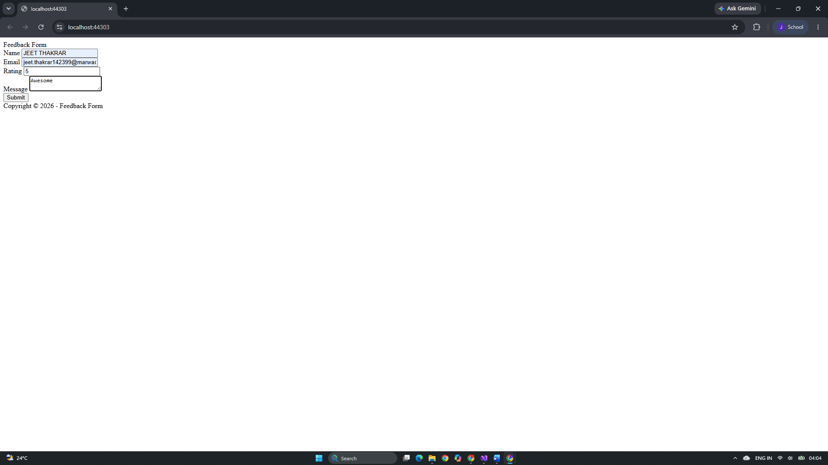
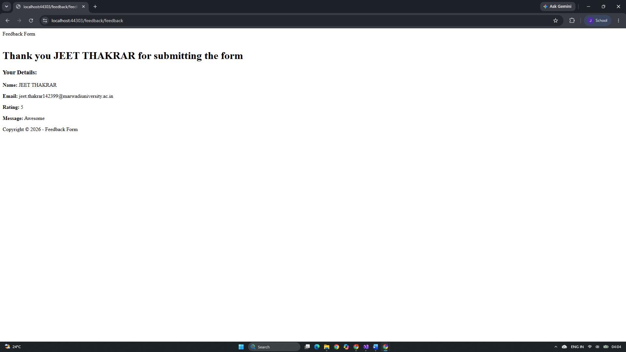

Github Url: https://github.com/jd-thakrar/Uni-DotNet-Work/tree/master/Practical-7/Practical-7

